SECRETS in GITHUB ACTIONS

1. What is a GitHub Secret?
A GitHub Secret is a sensitive value stored securely in GitHub and made available to a GitHub Actions workflow when needed.
Examples:
DOCKER_PASSWORD
AWS_ACCESS_KEY
AWS_SECRET_KEY
API_TOKEN
DATABASE_PASSWORD
SSH_PRIVATE_KEY
Instead of putting the actual password inside your code:
password: MyPassword123
we store it in GitHub:
GitHub Repository
│
└── Settings
│
└── Secrets and variables
│
└── Actions
Then in the workflow we refer to it by name:
${{ secrets.DOCKER_PASSWORD }}
The actual value is not written in the YAML file.

2. Why do we need GitHub Secrets?
❌ Without Secrets
Imagine your GitHub Actions file contains:
- name: Login to Docker Hub
run: docker login -u akshat -p MyPassword123
The problem is:
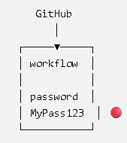
Anyone who gets access to the repository/code could potentially discover the credential.

✅ With GitHub Secrets
Instead:
- name: Login to Docker Hub
uses: docker/login-action@v4
with:
username: ${{ secrets.DOCKER_USERNAME }}
password: ${{ secrets.DOCKER_PASSWORD }}
The architecture becomes:
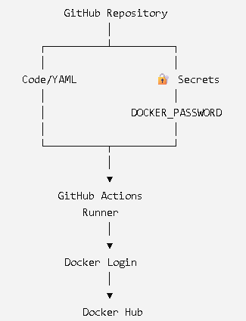

Code tells GitHub WHAT to use. Secrets provide the sensitive VALUE.
For example:
password: ${{ secrets.DOCKER_PASSWORD }}
means:
"GitHub, get the value of DOCKER_PASSWORD from the secure Secrets store and provide it to this step."
#############
PRACTICAL :

Create a github repo
Create -> .github/workflows/secret.yml
name: Docker Login Demo
on:
push:
branches:
- master
jobs:
docker:
runs-on: ubuntu-latest
steps:
- name: Checkout Code
uses: actions/checkout@v4
- name: Login to Docker Hub
uses: docker/login-action@v4
with:
username: ${{ secrets.DOCKER_USERNAME }}
password: ${{ secrets.DOCKER_PASSWORD }}
- name: Check Docker
run: docker info

## NOW LETS CREATE SECRET

Click on setting
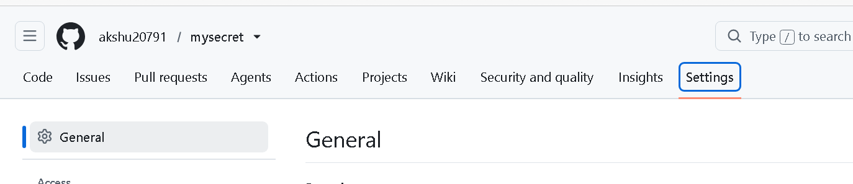
Secrets and variables -> Actions
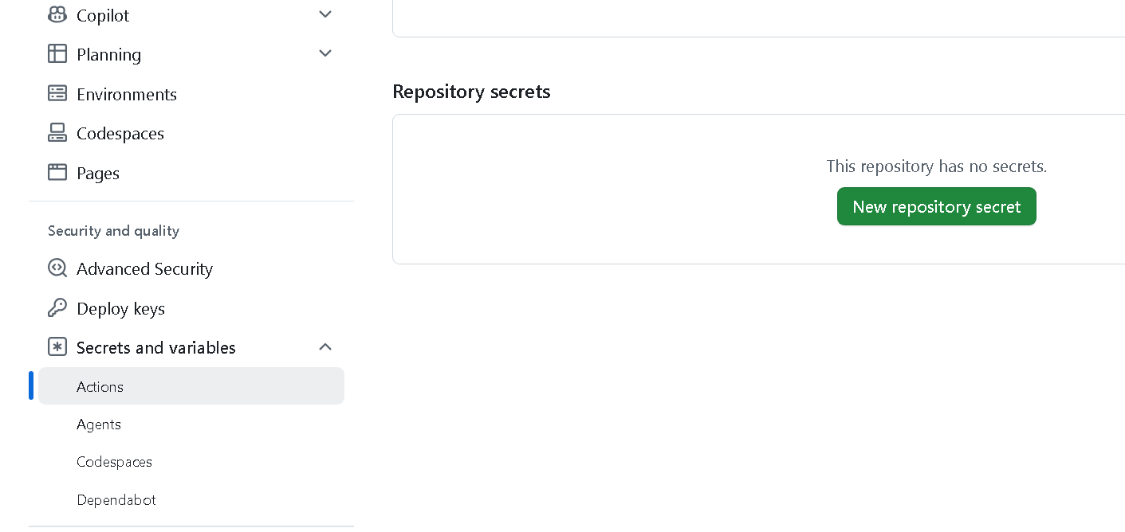
Click on new repository secret
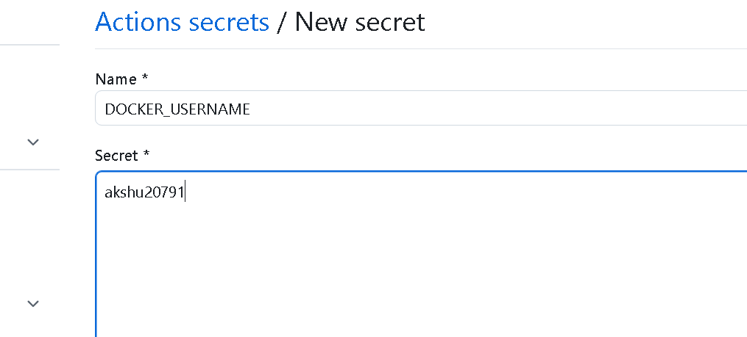
Again Add repo secret
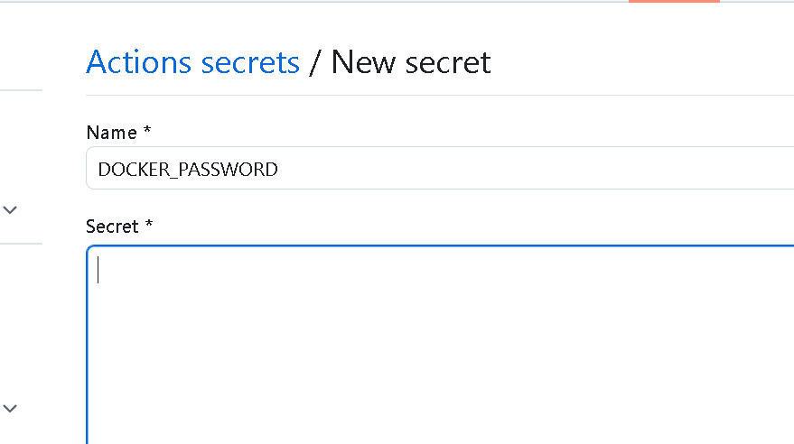
In secret put the password
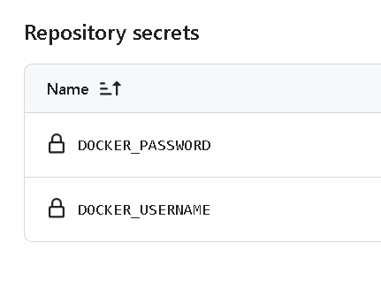
Now check go to actions and check

